School Of Mechanical & Manufacturing Engineering, NUST

Department of Mechanical Engineering

CS-114 - Fundamental of Programing

Lab Manual # 07

**Course Instructor:** Dr Khwaja Fahad Iqbal

**Lab Instructor:** Muhammad Affan

**Student Name: ZORAIZ ABBAS**

**CMS ID: 454752**

**DATE:**

**16 NOV 2023**

Fundamental of Programing

**Task 1:**

Take 10 integer inputs from user and store them in an array and print them on screen.

**Answer:**

#include<iostream>

using namespace std;

int main(){

int arr[9];

cout<<"Enter ten numbers: "<<endl;

for(int i=0;i<=9;i++){

cin>>arr[i];

}

for(int i=0;i<=9;i++){

cout<<arr[i]<<" ";

}

return 0;

}

**Result:**

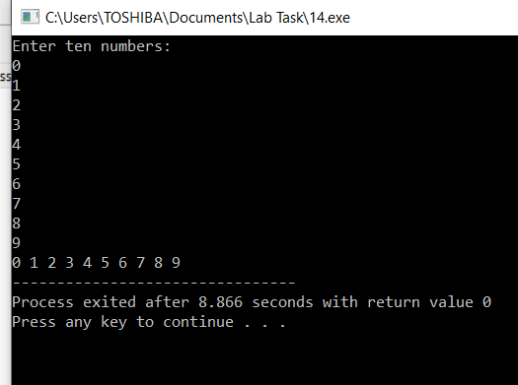

**Task 2:**

Write a program to find the sum and product of all elements of an array with 5 integer elements.

**Answer:**

#include<iostream>

using namespace std;

int main(){

int arr[5],sum=0,product=1;

cout<<"enter your desired five numbers: "<<endl;

for(int i=0;i<=4;i++){

cin>>arr[i];

sum+=arr[i];

product*=arr[i];

}

cout<<"The sum of the numbers is: "<<sum<<endl;

cout<<"The product of the numbers is: "<<product<<endl;

return 0;

}

**Answer:**

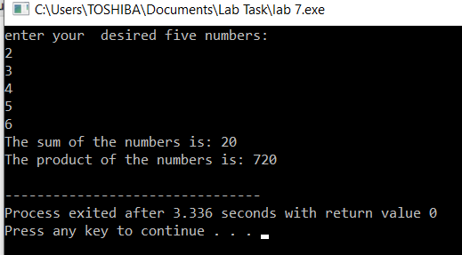

**Task 3:**

#include<iostream>

using namespace std;

int main(){

int n, half;

cout<<"Enter the diamond size in terms of odd number only: "<<endl;

cin>>n;

char arr[n];

half=n/2;

for(int i=0;i<n;i++){

arr[i]=' ';}

for(int i=0;i<=half;i++){

for(int j=0;j<n;j++){

arr[half-i]='*';

arr[half+i]='*';

cout<<arr[j];

}

cout<<endl;

}

for(int i=half;i>=0;i--){

for(int j=0;j<n;j++)

{

arr[half-i]=' ';

arr[half+i]=' ';

cout<<arr[j];

}

cout<<endl;

}

return 0;

}

**Result:**

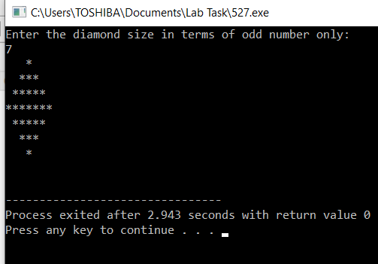

**The end**